你關心的關鍵詞的情緒分析

Take a look at the demonstration website.

Let’s get started!

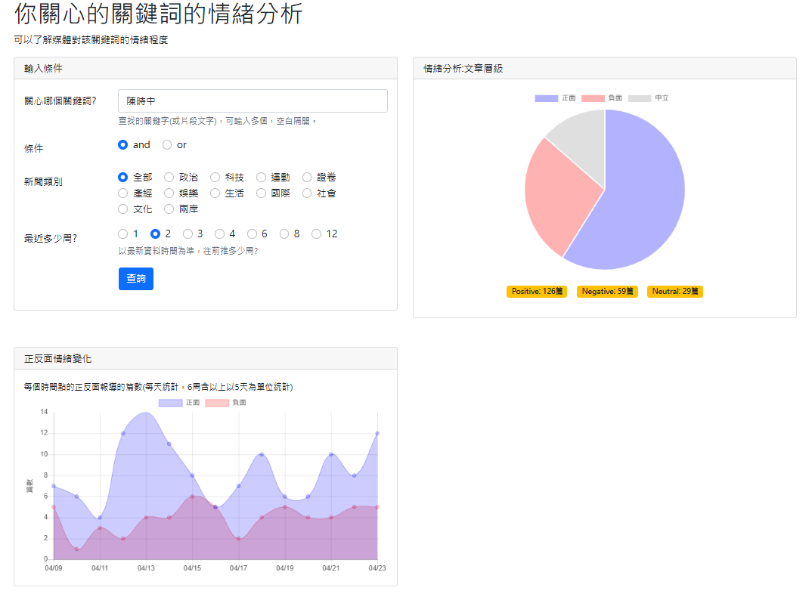

Step 0: Create a project by duplicating previous project

We will continue from our previous project.

Step1: Open the project with your favorite Editor

Open our project using VS Code.

Step 2: Create “app_user_keyword_sentiment”

Step 2: Create a new APP named “app_user_keyword_sentiment” in your website root.

python manage.py startapp app_user_keyword_sentiment

Step3: (Optional)Copy data file to the dataset folder

We will use the preprocessed data file, so copy it into the dataset folder.

We have done this in our previous app.

Step 4: settings.py

|  |  |
| --- | --- |
| |  | | --- | | ALLOWED_HOSTS = ['*']  INSTALLED_APPS = [  …..  'app_user_keyword_sentiment',  ] | |

Step 5: website_configs/urls.py

website_configs/urls.py

|  |  |
| --- | --- |
| |  | | --- | | # user keyword sentiment  path('userkeyword_senti/', include('app_user_keyword_sentiment.urls')), | |

Step 6: app_user_keyword_sentiment/urls.py

In folder app_user_keyword_sentiment, create a Python file named “urls.py”.

app_user_keyword_sentiment/urls.py

|  |  |
| --- | --- |
| |  | | --- | | from django.urls import path  from . import views  app_name="app_user_keyword_sentiment"  urlpatterns = [  path('', views.home, name='home'),  path('api_get_userkey_sentiment/', views.api_get_userkey_sentiment),  path('api_get_userkey_sentiment_from_remote_api_through_backend/', views.api_get_userkey_sentiment_from_remote_api_through_backend),  ] | |

Step 7: views.py

從別處App叫用filter_dataFrame

from app_user_keyword.views import filter_dataFrame

後端呼叫他處API

由後端呼叫他處API，取得情感分析數據。

另一種方式是由前端呼叫遠端API

由後端呼叫比較有彈性。

|  |
| --- |
| @csrf_exempt  def api_get_userkey_sentiment(request):  userkey = request.POST['userkey']  cate = request.POST['cate']  cond = request.POST['cond']  weeks = int(request.POST['weeks'])      # 展示從後端呼叫API: Call internet sentiment API using requests  url_api_get_sentiment = "http://163.18.23.20:8000/userkeyword_senti/api_get_userkey_sentiment/"  # Setup data for sentiment analysis request  sentiment_data = {  'userkey': userkey,  'cate': cate,  'cond': cond,  'weeks': weeks  }  # Alternative way to call the sentiment API directly with requests  sentiment_response = requests.post(url_api_get_sentiment, data=sentiment_data)  if sentiment_response.status_code == 200:  print("由後端呼叫他處API，取得情感分析數據成功!")  response_sentiment = sentiment_response.json()  return JsonResponse(response_sentiment)  else:  print(f"Sentiment API error: {sentiment_response.status_code}")  print(f"呼叫失敗則進行本地處理資料")  return JsonResponse({'error': 'Failed to get sentiment analysis.'}) |

views.py

|  |
| --- |
|  |

Step 8: home.html

In the app folder, create a HTML file named “home.html”

app_user_keyword_sentiment/templates/app_user_keyword_sentiment/home.html

home.html

|  |
| --- |
|  |

Step 9: base.html

Step 10: Run server

python manage.py runserver 8000

What does your web page look like?